15IT304J – WEB PROGRAMMING LAB

**SEMESTER – VI**

# ONLINE NOTES PORTAL

# MUSKAN SINGHAL

# RA1711008010070

# IT 403

# 



**FACULTY OF ENGINEERING AND TECHNOLOGY SRM INSTITUTE OF SCIENCE AND TECHNOLOGY**

**(Under Section 3 of UGC Act, 1956)**

**S.R.M. NAGAR, KATTANKULATHUR – 603203**

**KANCHEEPURAM DISTRICT**

**Ex.No.: 1 a) Create a login page for your project using HTML.**

**b) Create a user registration page of the project with all possible form elements.**

**Hints:**

• Create a banner for page header using any image editor (Photoshop, MS Paint, etc.)

• Create a footer content

• HTML tags: paragraph, h1 to h6, anchor, fonts, lists

• Form elements: input box, password, list box, check box, button, radio button, option button.

• HTML 5: audio, video tags

• Layouts using tables, div and span, HTML structural elements.

**USER HOME PAGE:**

**USER HOME PAGE AFTER USING CSS:**



**USER NAVIGATION PAGE USING SEMANTIC ELEMENTS:**



**home.html**

<!DOCTYPE html>

<html>

<head>

<title>Web Programming</title>

</head>

<style>

div.align{

text-align: center; }

div.lists{

font-size: 130%;

font-family: georgia;

color: #ffcccc;

position:fixed; right:40px; bottom: 5px; }

body {

background-image: url('notes4.jpg');

background-repeat: no-repeat;

background-size: cover;

background-attachment: fixed; }

#Sidenav a {

position: absolute; left: -80px;

transition: 0.3s; padding: 15px;

width: 100px; text-decoration: none;

font-size: 20px; color: black;

border-radius: 0 5px 5px 0; }

#Sidenav a:hover {

left: 0;

background: white; }

#about {

top: 20px; background-color: #4CAF50; }

#login {

top: 80px;

background-color: #2196F3; }

#signup {

top: 140px; background-color: #f44336; }

</style>

<body>

<div id="Sidenav" class="sidenav">

<a href="file:///C:/Users/Muskan/Desktop/about.html?" id="about">About</a>

<a href="file:///C:/Users/Muskan/Desktop/login.html?" id="login">Login</a>

<a href="file:///C:/Users/Muskan/Desktop/register.html?" id="signup">Signup</a>

</div>

<div class="align">

<h1 style="font-family: georgia; font-size: 320%; color: white"><br>

<br> <br><b>MyNotes</h1>

<p style="font-size: 150%; font-family:georgia; color: khaki;">Access. Study. Ace.</b></p>

</div>

<div class="lists">

<ul>

<li>Access the material</li>

<li>Study without hassle</li>

<li>Ace the exams</li>

</ul>

</div>

</body>

</html>

**about.html**

<!DOCTYPE html>

<html>

<head>

<title>ABOUT</title>

</head>

<style>

body{

font-size: 150%;

font-family: georgia; color: white;

background-image: url('about.jpeg');

background-repeat: no-repeat;

background-size: cover;

background-attachment: fixed; }

</style>

<body>

<main>

<article>

<header> <br> <b> <u>What is MyNotes?</u></b><br></header>

<br> It is a <mark>notes portal for students of SRM Institute of Science and Technology,<br> mainly from the IT and CSE department</mark>. <BR> Students will be able to access different notes as well as question papers for multiple courses.

</article>

<section>

<h><b><u><br>Main Courses</u></b></h>

<p>

<ul>

<li>DBMS</li>

<li>Computer Networks</li>

<li>Operating Systems</li>

<li>Microprocessors and Microcontrollers</li>

<li>Python</li>

<li>Data Structures<br></li>

</ul> </p> </section>

<details><br>

In case anyone wants to add or edit any of the notes material or question papers <br> they are requested to kindly contact on the email given below.<br> </details>

<footer><br>

<p>Contact information: <a href="mailto:mynotes@srmist.edu.in">

mynotes@srmist.edu.in</a>.</p> </footer>

</main>

</body>

</html>

**RESULT : User home page and about page using css and login register page have been created successfully.**

**Ex.No.: 2 a) Format the login page using CSS 3.0**

**b) Format the user registration page using CSS3.0**

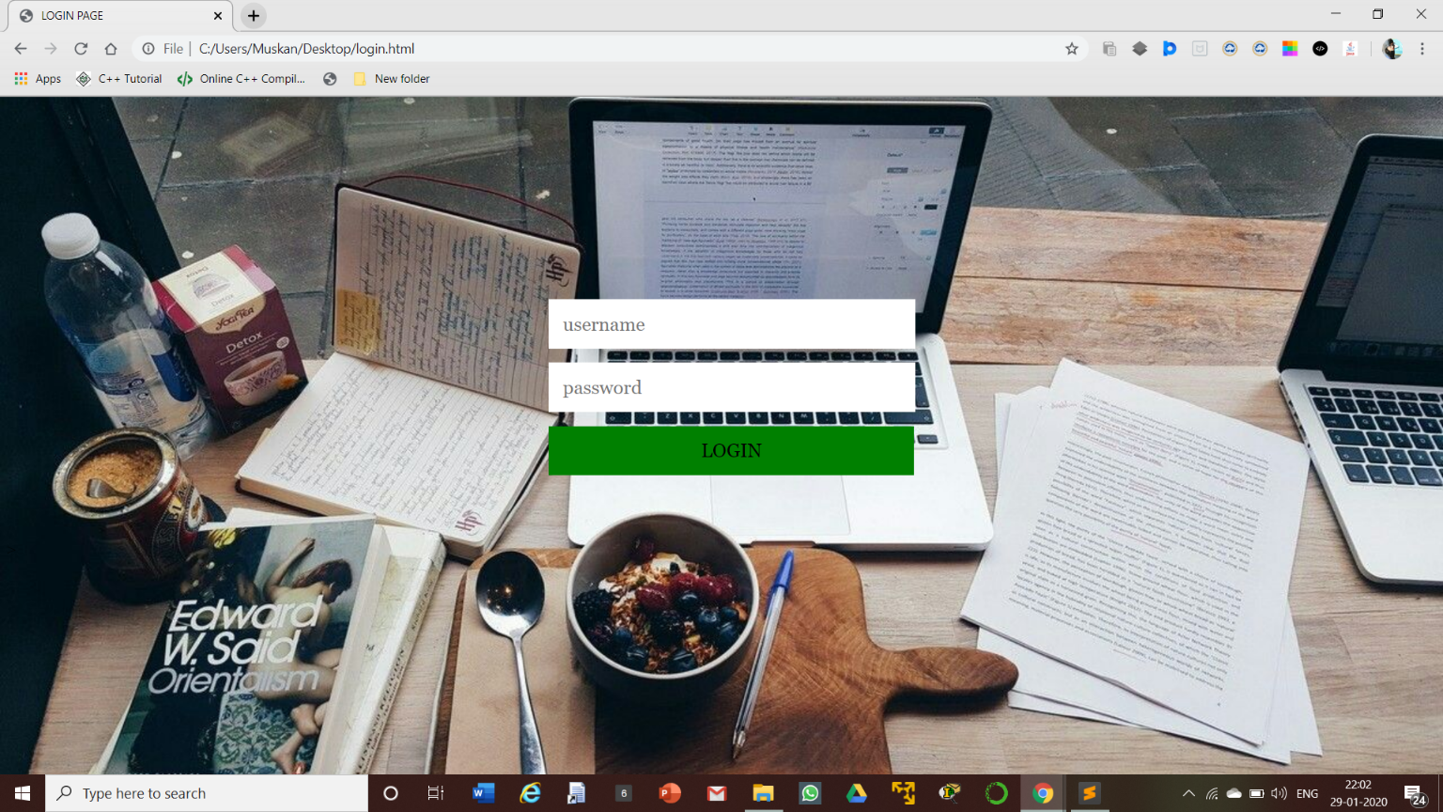**LOGIN PAGE AFTER USING CSS:**

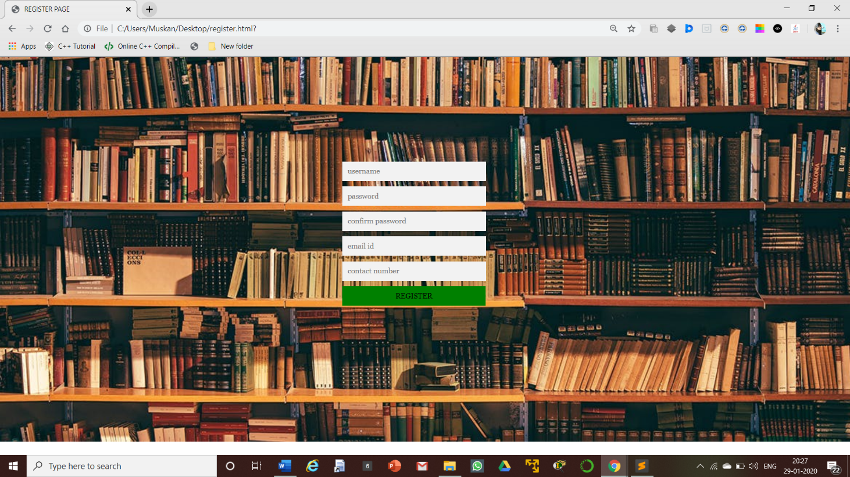**SIGNUP PAGE AFTER USING CSS:**

**login.html**

<!DOCTYPE html>

<html>

<head>

<title>LOGIN PAGE</title>

<link rel="stylesheet" href="style2.css">

</head>

<body>

<div class="login">

<div class="form"> <form class="login form">

<input type="text" placeholder="username"/>

<input type="password" placeholder="password"/>

<button>Login</button>

</form> </div>

</div>

</body>

</html>

**style2.css**

body{

background-image: url(noteswp.jpg);

height: 95vh; width: 190vh;

background-size: cover;

background-position: center;

background-repeat: no-repeat; }

.login{

width: 360px; padding: 10% 0 0; margin: auto; }

.form{

position: relative; max-width: 360px;

margin: auto auto auto; padding: 35px;

text-align:center; }

.form input{

font-family: "georgia"; outline: 1;

background: white; width: 100%;

border: 0; margin: 0 0 15px;

padding: 15px; box-sizing: border box;

font-size: 20px; }

.form button

{ font-family: georgia; text-transform: uppercase;

outline: 0; background-color: green;

width: 108%; border: 0;

padding: 15px; color: black;

font-size: 20px; cursor: pointer; }

.form button:hover, .form button:active

{ background: gray; }

**register.html**

<!DOCTYPE html>

<html>

<head>

<title>REGISTER PAGE</title>

<link rel="stylesheet" href="style.css">

</head>

<body>

<div class="signup">

<div class="form"> <form class="signup form">

<input type="text" placeholder="first name" id="fname" name="firstname" required/>

<input type="text" placeholder="last name" id="lname" name="lastname" required/>

<input type="date" placeholder="birthday" id="dob" name="birthday" required >

<input type="text" placeholder="age" id="age" name="age" required>

<input type="text" placeholder="username" id="name" name="username" required/>

<input type="password" id="password" placeholder="password" name="password" required />

<input type="password" id="confirm" placeholder="confirm password" name="cpassword" required/>

<input type="email" placeholder="email id" id="mail" name="email" required/>

<input type="text" id="phone" placeholder="contact number" name="phone" required /> <button>Register</button>

</form> </div>

</div>

</body>

</html>

**style.css :**

body{

background-image: url(notes3.jpg);

height: 95vh; width: 190vh;

background-size: cover;

background-position: center;

background-repeat: no-repeat; }

.signup{

width: 360px; padding: 10% 0 0; margin: auto; }

.form{

position: relative; max-width: 360px;

margin: auto auto auto;

padding: 35px; text-align:center; }

.form input{

font-family: "georgia"; outline: 1;

background: #f2f2f2; width: 100%;

border: 0; padding: 15px;

margin: 0 0 15px;

box-sizing: border box;

font-size: 20px; }

.form button

{ font-family: georgia;

text-transform: uppercase;

outline: 0; background-color: green;

width: 108%; border: 0;

padding: 15px; color: black;

font-size: 20px;

cursor: pointer; }

.form button:hover, .form button:active{

background: gray; }

**RESULT : Login and Registration pages have been formatted successfully using CSS 3.0.**

**Ex. No.: 3 Validating user inputs of the web pages using Java Script**

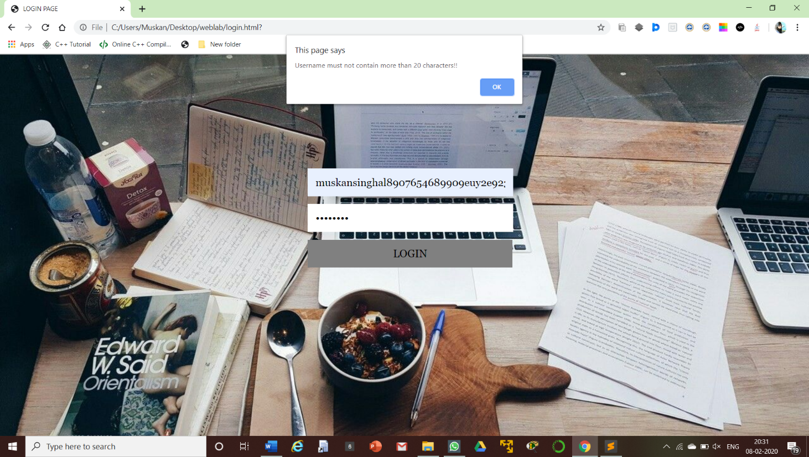**LOGIN PAGE VALIDATION**

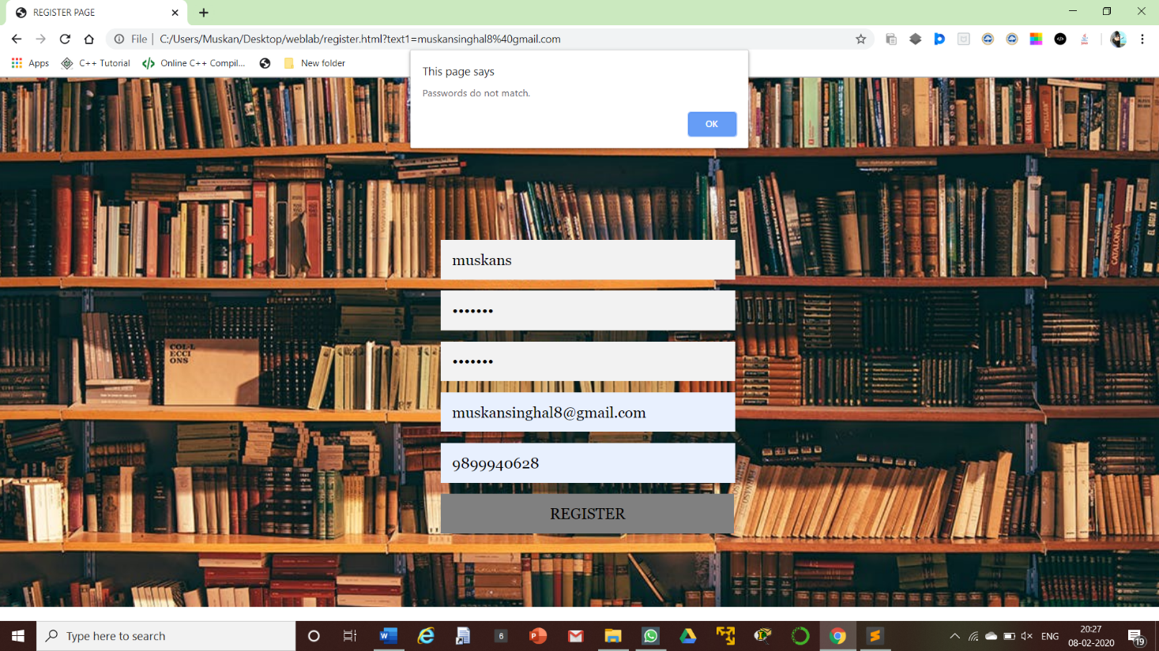**SIGNUP PAGE VALIDATION**

**resgister.javascript**

<script type="text/javascript">

function uvalidate()

{ var un=document.getElementById("name").value;

var fname=document.getElementById("fname").value;

var lname=document.getElementById("lname").value;

var password = document.getElementById("password").value;

var confirmPassword = document.getElementById("confirm").value;

re=/^[A-Z][a-z]+$/;

if (!re.test(fname)) {

alert("First Name must start with a capital letter");

return false; }

if(!re.test(lname))

{

alert("Last Name must start with a capital letter")

return false; }

re2=/^[a-z][a-z0-9]{6,18}$/;

if(!re2.test(un))

{

alert("Username must contain only letters and numbers of length 6 to 18 chracters!!");

return false; }

if (password != confirmPassword)

{

alert("Passwords do not match.");

return false; }

re3=/[A-Za-z0-9]{6,15}/

if(!re3.test(password))

{

alert("Password must contain letters and numbers of length 6 to 15!!");

return false; }

var mobileno= document.getElementById("phone").value;

if(mobileno.length != 10)

{

alert("Please enter valid contact number!!");

return false; }

var age= document.getElementById("age").value;

if(age<18)

{ alert("Valid registration age is 18 and above!! ");

return false; }

return true; }

</script>

**login.javascript**

<script type="text/javascript">

function uvalidate()

{ var un=document.getElementById("name").value;

var pw=document.getElementById("password").value;

re2=/^[a-z][a-z0-9]{6,18}$/;

if(!re2.test(un))

{

alert("Username must contain only letters and numbers of length 6 to 18 chracters!!");

return false; }

re3=/[A-Za-z0-9]{6,15}/

if(!re3.test(pw))

{

alert("Password must contain letters and numbers of length 6 to 15!!");

return false; }

return true;

}

</script>

**RESULT : Login and Registration page inputs have been successfully validated using javascript.**

**Ex. No.: 4 a) Create a *mysql* database and all the tables of the project in *phpmyadmin*. b) Write a PHP code to store user registration information in the database. c) Write a PHP code for user login page.**

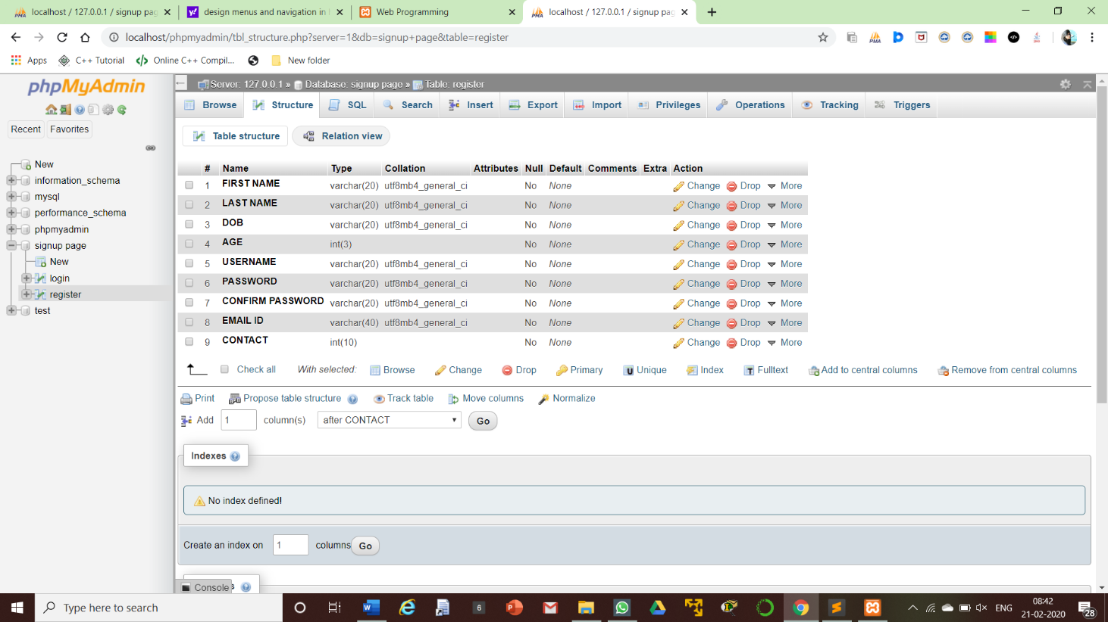**DATABASE TABLE FOR STORING USER INPUTS**

**include in register.php code**

<form class="signup form" method="post" action="insert.php">

**insert.php**

<?php

$firstname = $_POST['firstname'];

$lastname = $_POST['lastname'];

$birthday = $_POST['birthday'];

$age= $_POST['age'];

$username= $_POST['username'];

$password= $_POST['password'];

$cpassword= $_POST['cpassword'];

$email = $_POST['email'];

$phone= $_POST['phone'];

if(!empty($firstname) || !empty($lastname) || !empty($birthday) || !empty($age) || !empty($username) || !empty($password) || !empty($cpassword) || !empty($email) || !empty($phone))

{

$host = "localhost";

$dbUsername = "root" ;

$dbPassword = "" ;

$dbname = "signup page" ;

$conn = new mysqli($host, $dbUsername, $dbPassword, $dbname);

if(mysqli_connect_error())

{

die('Connection error('. mysqli_connect_errno().')'. mysqli_connect_error());

}

else

{ $SELECT = "SELECT email from register where email=? Limit 1";

$INSERT = "INSERT into register(firstname, lastname, birthday, age, username, password, cpassword, email, phone) values(?,?,?,?,?,?,?,?,?) ";

$stmt = $conn->prepare($SELECT);

$stmt->bind_param("s", $email);

$stmt->execute();

$stmt->bind_result($email);

$stmt->store_result();

$rnum = $stmt->num_rows;

if($rnum==0)

{ $stmt->close();

$stmt = $conn->prepare($INSERT);

$stmt->bind_param("sssissssi", $firstname, $lastname, $birthday, $age, $username, $password, $cpassword, $email, $phone);

$stmt->execute();

header("location:login.php"); }

else { echo "Email id already registered, try again using another email.";}

$stmt->close(); $conn->close();

}

}

else { echo "All fields are required.";

die();

}

?>

**include in login.php code**

<form class="login form" method="post" action="login2.php">

**login2.php**

<?php

$username= $_POST['username'];

$password= $_POST['password'];

if(!empty($username) || !empty($password))

{

$host = "localhost";

$dbUsername = "root" ;

$dbPassword = "" ;

$dbname = "signup page" ;

$conn = new mysqli($host, $dbUsername, $dbPassword, $dbname);

if(mysqli_connect_error())

{

die('Connection error('. mysqli_connect_errno().')'. mysqli_connect_error());

}

else

{ $SELECT = "SELECT username from register where username=? Limit 1";

$stmt = $conn->prepare($SELECT);

$stmt->bind_param("s", $username);

$stmt->execute();

$stmt->bind_result($username);

$stmt->store_result();

$rnum = $stmt->num_rows;

if($rnum==1)

{

header("location:home.php");

//echo "Login successfully";

}

else

{ header("location:register.php");

//echo "Login failed, username does not exists.";

}

$stmt->close(); $conn->close();

}

}

else

{

echo "All fields are required.";

die();

}

?>

**RESULT : Database connection and PHP code for Login and Register page has been executed successfully.**

**Ex. No.: 5 Design menus and navigation of the project.**



ul {

list-style-type: none;

margin: 0; padding: 0; overflow: hidden;

background-color: black;

position:fixed; right:40px; top: 5px;

font-family: georgia;

}

li { float: left; }

li a {

display: block; color: white;

text-align: center;

padding: 14px 16px;

text-decoration: none; }

li a:hover:not(.active) {

background-color: white; color: black; }

.active { background-color: black; }

<ul>

<li><a href="#http://localhost/home.php">HOME</a></li>

<li><a href="http://localhost/about.php">ABOUT</a></li>

<li><a href="http://localhost/login.php">LOGIN</a></li>

<li><a href="http://localhost/register.php">SIGNUP</a></li>

</ul>

**RESULT : Menus and navigations implemented successfully.**

**Ex. No.: 6 Implement business logic of the project.**

**Instruction:**

According to the students project appropriate business logic can be implemented with the required database insertion and retrieval operations.

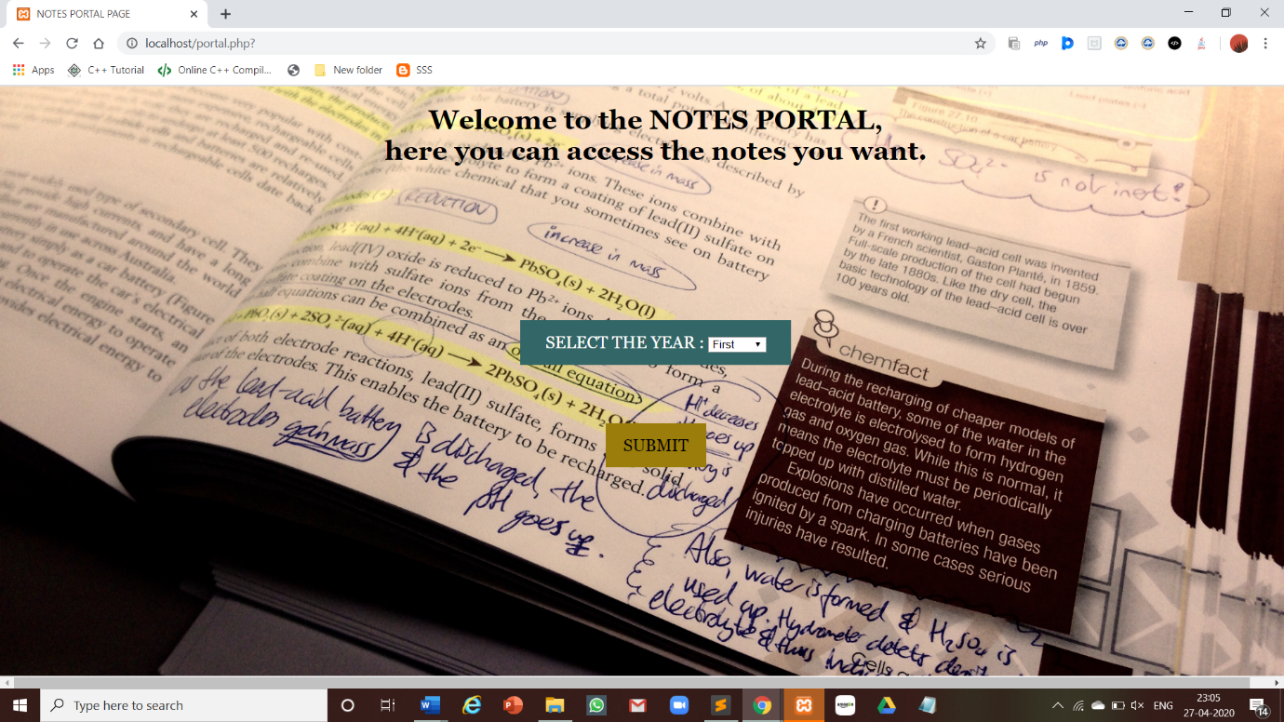

**portal.php**

<!DOCTYPE html>

<html>

<head>

<title>NOTES PORTAL PAGE</title>

<link rel="stylesheet" href="portalstyle.css">

</head>

<body>

<div class="head">

<h1>Welcome to the NOTES PORTAL,<br>here you can access the notes you want.</h1>

</div>

<div class="form">

<form>

<button>

SELECT THE YEAR : <select name="Year">

<option value="First">First</option>

<option value="Second">Second</option>

<option value="Third">Third</option>

<option value="Fourth">Fourth</option>

</select>

</button>

</form>

</div>

<div class="form1">

<form>

<button>SUBMIT</button>

</form>

</div>

</body>

</html>

**portalstyle.css**

body

{

background-image: url(portal.jpg);

height: 52vh;

width: 215vh;

background-size: cover;

background-position: center;

background-repeat: no-repeat;

}

.head

{

text-align: center;

font-family: georgia;

}

.form{

position: relative;

max-width: 360px;

margin: 150px auto auto;

padding: 35px;

text-align:center;

}

.form button

{

font-family: georgia;

outline: 0;

background-color: #336666;

width: 90%;

border: 0;

padding: 15px;

color: white;

font-size: 20px;

cursor: pointer;

}

.form1{

position: relative;

max-width: 360px;

margin: auto auto auto;

padding: 35px;

text-align:center;

}

.form1 button

{

font-family: georgia;

background-color: #9A7D0A;

width: 120px;

border: 0;

padding: 15px;

color: black;

font-size: 20px;

cursor: pointer;

}

.form1 button:hover, .form button:active{

background: #FCF3CF;

}

**RESULT : Business Logic of the project has been successfully implemented.**

**Ex. No.:7 Create a cookie to save the username and password and display it in the respective field when the user returns to the webpage.**

**login.php**

<!DOCTYPE html>

<html>

<head>

<title>LOGIN PAGE</title>

<link rel="stylesheet" href="style2.css">

</head>

<body>

<div class="login">

<div class="form">

<form class="login form" method="post" action="login2.php">

<input type="text" placeholder="username" id="name" name="username" value="<?php echo Cookie_val(1) ?>" required/>

<input type="password" placeholder="password" id="password" name="password" value="<?php echo Cookie_val(2) ?> " required/>

<button onclick="return uvalidate()" >Login</button>

</form>

</div>

</div>

<?php

function Cookie_val($ch){

if ($ch==1)

{

if (isset($_COOKIE['username']))

{ return $_COOKIE['username']; }

else return; }

else

{

if (isset($_COOKIE['password']))

{ return $_COOKIE['password']; }

else return; }

}

?>

</body>

</html>

**login2.php**

<?php

$username= $_POST['username'];

$password= $_POST['password'];

;

if(!empty($username) || !empty($password))

{

$host = "localhost";

$dbUsername = "root" ;

$dbPassword = "" ;

$dbname = "signup page" ;

$conn = new mysqli($host, $dbUsername, $dbPassword, $dbname);

if(mysqli_connect_error())

{

die('Connection error('. mysqli_connect_errno().')'. mysqli_connect_error());

}

else

{

$SELECT = "SELECT username from register where username=? Limit 1";

$stmt = $conn->prepare($SELECT);

$stmt->bind_param("s", $username);

$stmt->execute();

$stmt->bind_result($username);

$stmt->store_result();

$rnum = $stmt->num_rows;

if($rnum==1)

{

header("location:portal.php");

if (isset($_POST['remuser'])){

setcookie("username",$username,time()+60*60*24);

setcookie("password",$password,time()+60*60*24); }

else

{

setcookie("username","",time()-5);

setcookie("password","",time()-5);

}

}

else

{ header("location:register.php");

//echo "Login failed, username does not exists.";

}

$stmt->close(); $conn->close();

}

}

else

{

echo "All fields are required.";

die();

}

?>

**RESULT : Cookie created successfully to perform the experiment.**

**Ex.No.: 8 Creating user registration page using Servlet and JSP.**

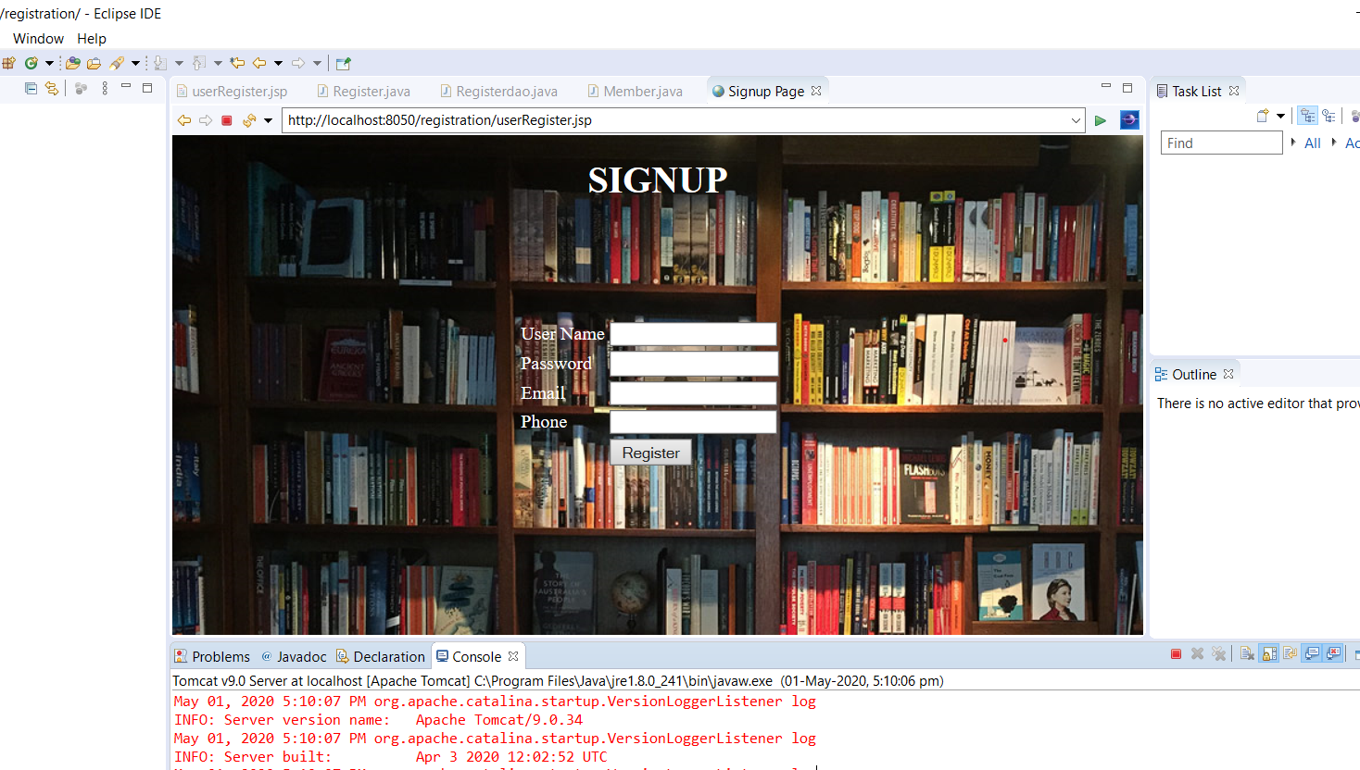

**userRegister.jsp**

<%@ page language=*"java"* contentType=*"text/html; charset=ISO-8859-1"*

pageEncoding=*"ISO-8859-1"*%>

<!DOCTYPE html>

<html>

<hFead>

<style>

div*.ex*{

color : *white*;

margin : *100px 290px auto*;

text-width : *bold*;

}

</style>

<meta charset=*"ISO-8859-1"*>

<title>Signup Page</title>

</head>

<body style="background-image: *url('http://www.embiggenbooks.com/wp-content/uploads/2015/10/gallery-inside-shop6.jpg')*;">

<h1 style="text-width : *bold*; color:*white*; text-align:*center*;">SIGNUP</h1>

<div class=*"ex"*>

<form action=*"Register"* method=*"post"*>

<table>

<tr>

<td>User Name</td>

<td><input type=*"text"* name=*"uname"*></td>

</tr>

<tr>

<td>Password</td>

<td><input type=*"password"* name=*"pwd"*></td>

</tr>

<tr>

<td>Email</td>

<td><input type=*"text"* name=*"email"*></td>

</tr>

<tr>

<td>Phone</td>

<td><input type=*"text"* name=*"phone"*></td>

</tr>

<tr>

<td></td>

<td><input type=*"submit"* value=*"Register"*></td>

</tr>

</table>

</form>

</div>

</body>

</html>

**Register.java**

import java.io.IOException;

import javax.servlet.ServletException;

import javax.servlet.annotation.WebServlet;

import javax.servlet.http.HttpServlet;

import javax.servlet.http.HttpServletRequest;

import javax.servlet.http.HttpServletResponse;

@WebServlet("/Register")

public class Register extends HttpServlet {

private static final long *serialVersionUID* = 1L;

public Register() {

super();

}

protected void doGet(HttpServletRequest request, HttpServletResponse response) throws ServletException, IOException {

response.getWriter().append("Served at: ").append(request.getContextPath());

}

protected void doPost(HttpServletRequest request, HttpServletResponse response) throws ServletException, IOException {

String uname = request.getParameter("uname");

String pwd = request.getParameter("pwd");

String email = request.getParameter("email");

String phone = request.getParameter("phone");

Member member = new Member(uname,pwd,email,phone);

Registerdao rdao = new Registerdao();

String result = rdao.Insert(member);

response.getWriter().print(result); }

}

**Registerdao.java**

import java.sql.Connection;

import java.sql.DriverManager;

import java.sql.PreparedStatement;

import java.sql.SQLException;

public class Registerdao {

private String dburl = "jdbc:mysql://localhost:3306/userdb";

private String dbuname = "root";

private String dbpwd = "";

private String dbdriver = "com.mysql.jdbc.Driver";

public void loadDriver(String dbDriver)

{

try {

Class.*forName*(dbDriver);

} catch (ClassNotFoundException e) {

// TODO Auto-generated catch block

e.printStackTrace();

}

}

public Connection getConnection()

{

Connection conn=null;

try {

conn = DriverManager.*getConnection*(dburl, dbuname, dbpwd);

} catch (SQLException e) {

// TODO Auto-generated catch block

e.printStackTrace();

}

return conn; }

public String Insert(Member member)

{

loadDriver(dbdriver);

Connection conn = getConnection();

String result = "Data enetered successfully";

String sql = "insert into userdb.Signup values (?,?,?,?)";

try {

PreparedStatement ps = conn.prepareStatement(sql);

ps.setString(1, member.getUname());

ps.setString(2, member.getPwd());

ps.setString(3, member.getEmail());

ps.setString(4, member.getPhone());

ps.executeUpdate();

} catch (SQLException e) {

// TODO Auto-generated catch block

e.printStackTrace();

result = "Data not entered, try again!";

}

return result;

}

}

**Member.java**

public class Member {

private String uname, pwd, email, phone;

public Member() {

super();

}

public String getUname() {

return uname;

}

public void setUname(String uname) {

this.uname = uname;

}

public String getPwd() {

return pwd;

}

public void setPwd(String pwd) {

this.pwd = pwd;

}

public String getEmail() {

return email;

}

public void setEmail(String email) {

this.email = email;

}

public String getPhone() {

return phone;

}

public void setPhone(String phone) {

this.phone = phone;

}

public Member(String uname, String pwd, String email, String phone) {

super();

this.uname = uname;

this.pwd = pwd;

this.email = email;

this.phone = phone;

}

}

**RESULT : User Registration Page using Servlet and JSP created successfully.**

**Ex.No.: 9 Design simple application for accessing the data using XML.**

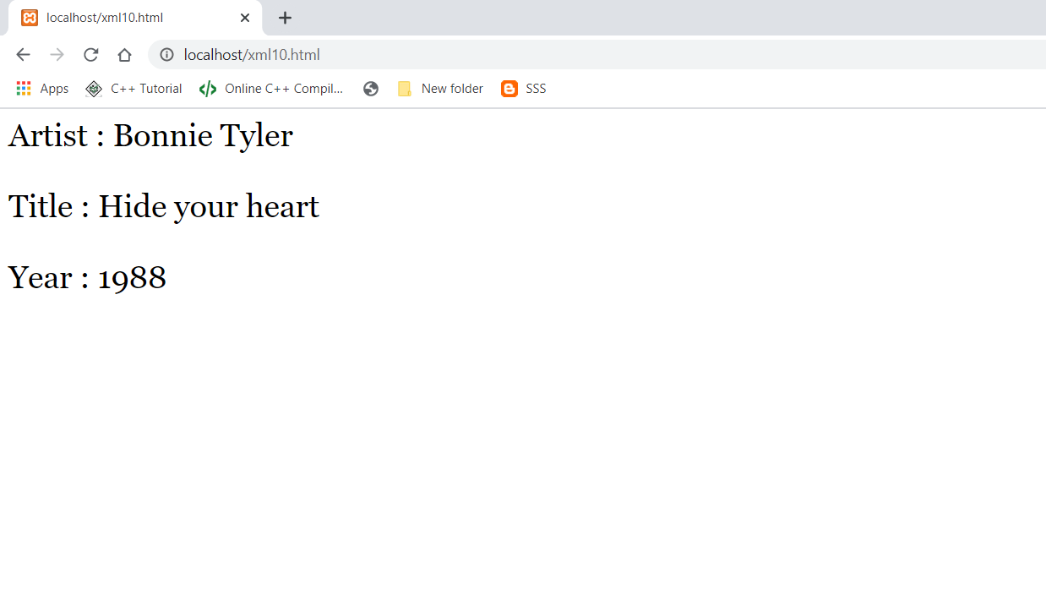

**xml10.html**

<!DOCTYPE html>

<html>

<body style="font-family: georgia; font-size: 30px">

<div id='showCD'></div>

<script>

displayCD(1);

function displayCD(i) {

var xmlhttp = new XMLHttpRequest();

xmlhttp.onreadystatechange = function() {

if (this.readyState == 4 ) {

myFunction(this, i);

}

};

xmlhttp.open("GET", "cd_catalog.xml", true);

xmlhttp.send();

}

function myFunction(xml, i) {

var xmlDoc = xml.responseXML;

x = xmlDoc.getElementsByTagName("CD");

document.getElementById("showCD").innerHTML =

"Artist : " +

x[i].getElementsByTagName("ARTIST")[0].childNodes[0].nodeValue +

"<br><br>Title : " +

x[i].getElementsByTagName("TITLE")[0].childNodes[0].nodeValue +

"<br><br>Year : " +

x[i].getElementsByTagName("YEAR")[0].childNodes[0].nodeValue;

}

</script>

</body>

</html>

**cd_catalog.html**

<CATALOG>

<CD> <TITLE>Empire Burlesque</TITLE> <ARTIST>Bob Dylan</ARTIST> <COUNTRY>USA</COUNTRY> <COMPANY>Columbia</COMPANY> <PRICE>10.90</PRICE> <YEAR>1985</YEAR> </CD>

<CD><TITLE>Hide your heart</TITLE><ARTIST>Bonnie Tyler</ARTIST> <COUNTRY>UK</COUNTRY> <COMPANY>CBS Records</COMPANY> <PRICE>9.90</PRICE> <YEAR>1988</YEAR> </CD>

<CD> <TITLE>Greatest Hits</TITLE> <ARTIST>Dolly Parton</ARTIST> <COUNTRY>USA</COUNTRY> <COMPANY>RCA</COMPANY> <PRICE>9.90</PRICE> <YEAR>1982</YEAR> </CD>

<CD> <TITLE>Still got the blues</TITLE> <ARTIST>Gary Moore</ARTIST> <COUNTRY>UK</COUNTRY> <COMPANY>Virgin records</COMPANY> <PRICE>10.20</PRICE> <YEAR>1990</YEAR> </CD>

<CD> <TITLE>Eros</TITLE> <ARTIST>Eros Ramazzotti</ARTIST> <COUNTRY>EU</COUNTRY> <COMPANY>BMG</COMPANY> <PRICE>9.90</PRICE> <YEAR>1997</YEAR> </CD>

<CD> <TITLE>One night only</TITLE><ARTIST>Bee Gees</ARTIST> <COUNTRY>UK</COUNTRY> <COMPANY>Polydor</COMPANY> <PRICE>10.90</PRICE> <YEAR>1998</YEAR> </CD>

<CD> <TITLE>Sylvias Mother</TITLE> <ARTIST>Dr.Hook</ARTIST> <COUNTRY>UK</COUNTRY> <COMPANY>CBS</COMPANY> <PRICE>8.10</PRICE> <YEAR>1973</YEAR> </CD>

<CD><TITLE>When a man loves a woman</TITLE> <ARTIST>Percy Sledge</ARTIST> <COUNTRY>USA</COUNTRY> <COMPANY>Atlantic</COMPANY> <PRICE>8.70</PRICE> <YEAR>1987</YEAR> </CD>

</CATALOG>

**RESULT : Simple application for accessing data using XML designed successfully.**

**Ex.No.: 10. Validating user registration form using AJAX.**

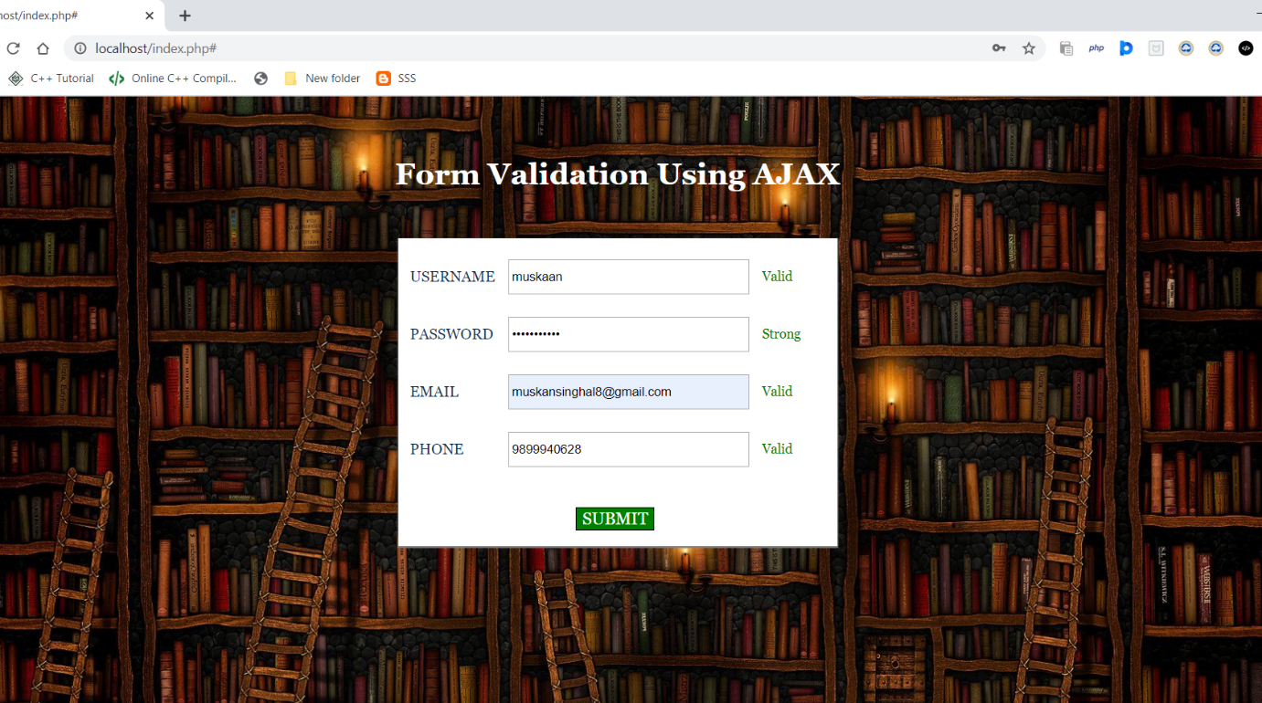

**index.php**

<!DOCTYPE html>

<html>

<head>

<link href="styleajaxvalid.css" rel="stylesheet" type="text/css">

<script src="script.js"></script>

</head>

<body>

<div id="mainform">

<div class="innerdiv">

<h1 >Form Validation Using AJAX</h1>

<form action='#' id="myForm" method='post' name="myForm">

<table>

<tr>

<td>USERNAME </td>

<td><input id='username1' name='username' onblur="validate('username', this.value)" type='text'></td>

<td>

<div id='username'></div>

</td> </tr>

<tr>

<td>PASSWORD </td>

<td><input id='password1' name='password' onblur="validate('password', this.value)" type='password'></td>

<td>

<div id='password'></div>

</td> </tr>

<tr>

<td>EMAIL </td>

<td><input id='email1' name='email' onblur="validate('email', this.value)" type='text'></td>

<td>

<div id='email'></div>

</td> </tr>

<tr>

<td>PHONE </td>

<td><input id='phone1' name='phone' onblur="validate('phone', this.value)" type='text'></td>

<td>

<div id='phone'></div>

</td> </tr>

</table>

<button onclick="checkForm()">SUBMIT</button>

</form>

</div>

</body>

</html>

**styleajaxvalid.css**

body{

background-image: url(ajaxbg.jpg);

height: 95vh;

width: 190vh;

background-size: cover;

background-position: center;

background-repeat: no-repeat;

color : white;

}

#mainform{

margin:20px 440px auto;

font-family:georgia;

}

#mainform h1{

width: 650px;

text-align:center;

margin : 65px -40px auto;

}

.innerdiv{

width:65%;

}

form{

background-color:#fff;

color:#123456;

box-shadow:0 1px 1px 1px gray;

width:450px;

margin:50px 250px 0 50px;

float:left;

height:310px;

padding:10px

}

input{

width:250px;

height:30px;

margin-top:10px;

border-radius:0px;

padding:2px;

margin:10px

}

button{

background-color:green;

border:1px solid black;

font-family:georgia;

font-weight:500;

font-size:18px;

color:white;

width:24 px;

margin-left:180px;

margin-top:30px

}

span{

color:green

}

#myForm div{

color:red;

font-size:14px

}

**script.js**

function checkForm() {

var name = document.getElementById("username1").value;

var password = document.getElementById("password1").value;

var email = document.getElementById("email1").value;

var phone = document.getElementById("phone1").value;

if (name == '' || password == '' || email == '' || phone == '') {

alert("Fill All Fields"); }

else {

var username1 = document.getElementById("username");

var password1 = document.getElementById("password");

var email1 = document.getElementById("email");

var phone1 = document.getElementById("phone");

if (username1.innerHTML == 'Must be 6+ letters' || password1.innerHTML == 'Password too short' || email1.innerHTML == 'Invalid email' || phone1.innerHTML == 'Invalid contact number') {

alert("Fill Valid Information");

document.getElementById("myForm").submit();

}

}

}

function validate(field, query) {

var xmlhttp;

if (window.XMLHttpRequest) {

xmlhttp = new XMLHttpRequest();

} else {

xmlhttp = new ActiveXObject("Microsoft.XMLHTTP");

}

xmlhttp.onreadystatechange = function() {

if (xmlhttp.readyState != 4 && xmlhttp.status == 200) {

document.getElementById(field).innerHTML = "Validating..";

} else if (xmlhttp.readyState == 4 && xmlhttp.status == 200) {

document.getElementById(field).innerHTML = xmlhttp.responseText;

} else {

document.getElementById(field).innerHTML = "Error Occurred. <a href='index.php'>Reload Or Try Again</a> the page.";

}

}

xmlhttp.open("GET", "validation.php?field=" + field + "&query=" + query, false);

xmlhttp.send();

}

**validation.php**

<?php

$value = $_GET['query'];

$formfield = $_GET['field'];

if ($formfield == "username") {

if (strlen($value) < 7) {

echo "Must be 6+ letters";

} else {

echo "<span>Valid</span>";

}

}

if ($formfield == "password") {

if (strlen($value) < 6) {

echo "Password too short";

} else {

echo "<span>Strong</span>";

}

}

if ($formfield == "email") {

if (!preg_match("/^\w+([\.-]?\w+)*@\w+([\.-]?\w+)*(\.\w{2,3})+$/", $value)) {

echo "Invalid email";

} else {

echo "<span>Valid</span>";

}

}

if ($formfield == "phone") {

if (strlen($value) != 10) {

echo "Invalid contact";

} else {

echo "<span>Valid</span>";

}

}

?>

**RESULT : Form validation using AJAX completed successfully.**

**Ex.No.: 11. Simple application for WEB SERVICES.**

INSTRUCTION : I have created a Calculator.java class for which the web services methods are :

**sum(int,int)**

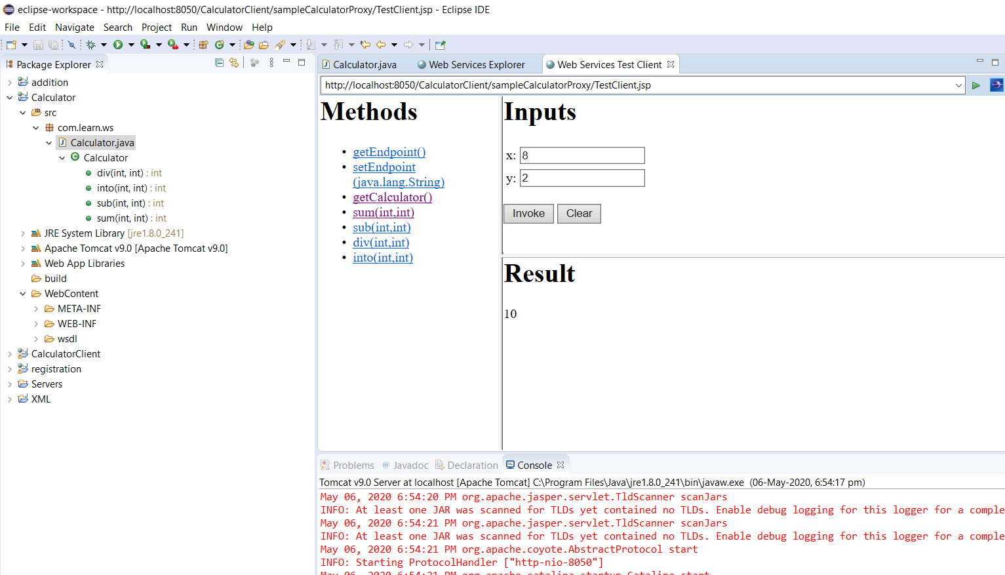

**sub(int,int)**

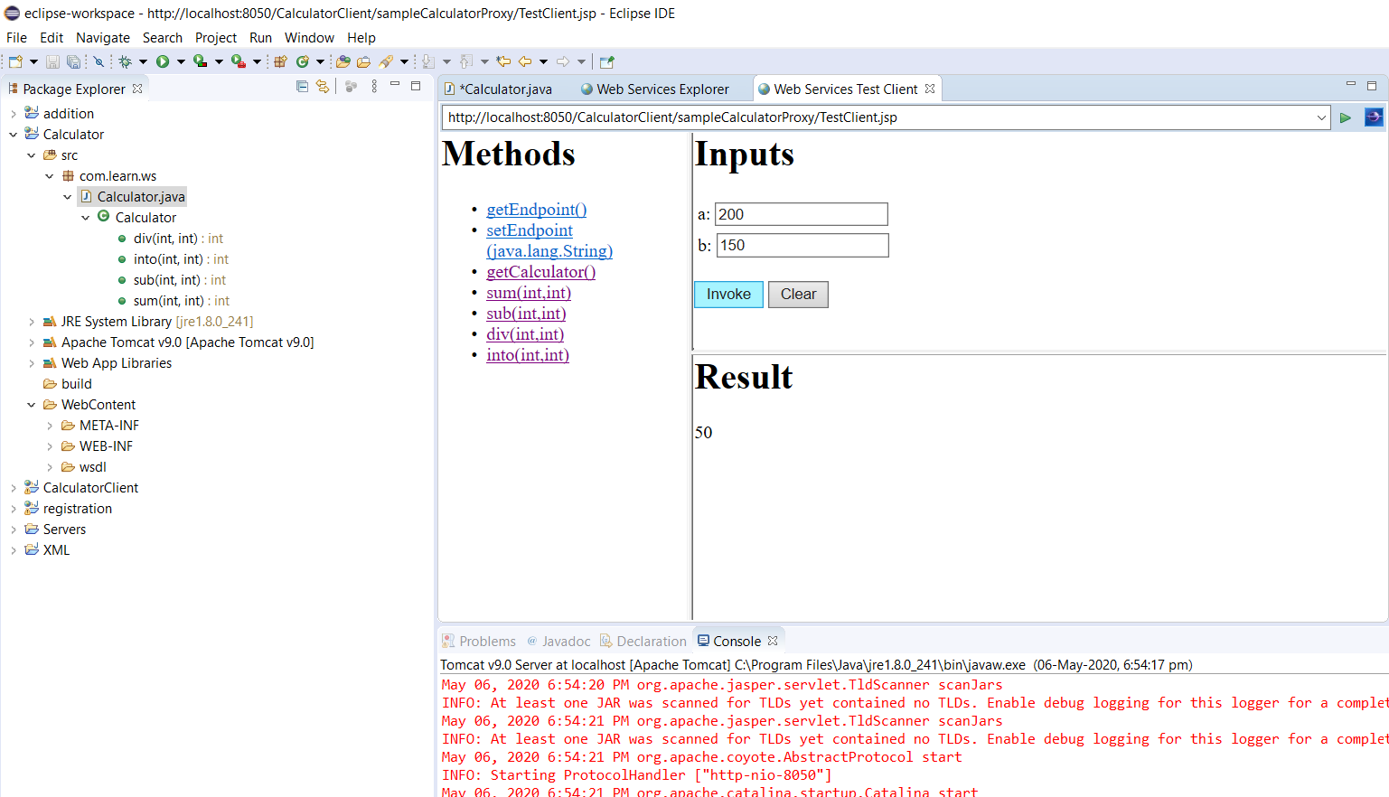

**div(int, int)**

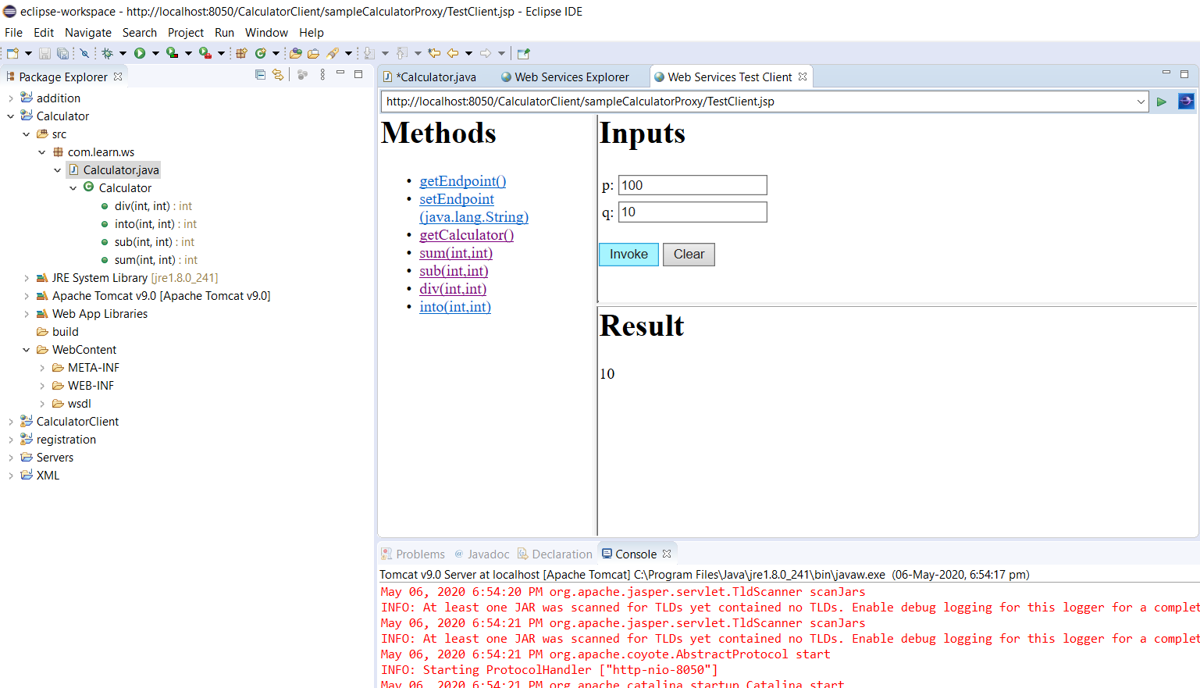

**into(int, int)**

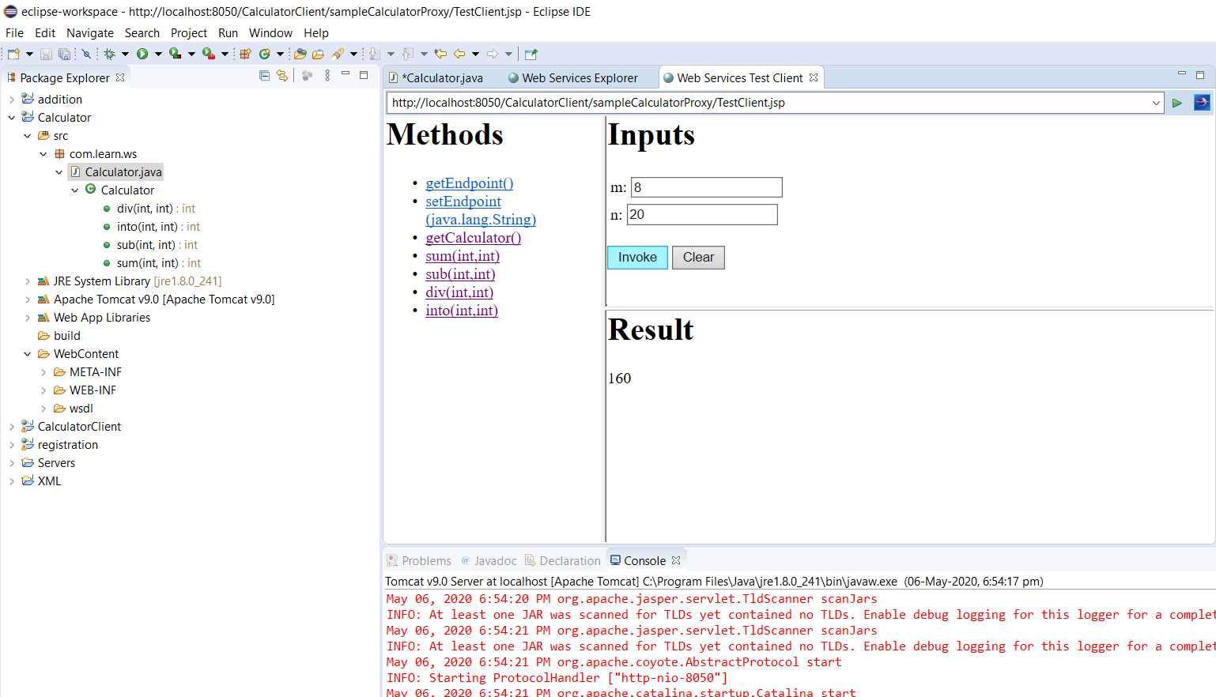

**Calculator.java**

package com.learn.ws;

public class Calculator

{

public int sum( int x, int y)

{

return (x+y) ;

}

public int sub(int a, int b)

{

return (a-b);

}

public int into(int m, int n)

{

return (m*n);

}

public int div(int p,int q)

{

return (p/q);

}

}

**RESULT : Calculator application using web services has been designed successfully.**